**Project Initialization and Planning Phase**

| Date | 9 JULY 2024 |
| --- | --- |
| Team ID | 739661 |
| Project Name | Anemiasense: Leveraging Machine Learning For Precise Anemia Recognitions |
| Maximum Marks | 3 Marks |

**Define Problem Statements (Customer Problem Statement Template):**

This structured problem statement template provides a clear overview of the issues addressed by the Anemiasense project, the proposed solution, and the criteria for success, ensuring alignment and clarity for stakeholders and collaborators.

- Current Situation

-Problem Identification

- **Impact of the problems**

**-** **proposed solution**

**-timeline**

**Example:**

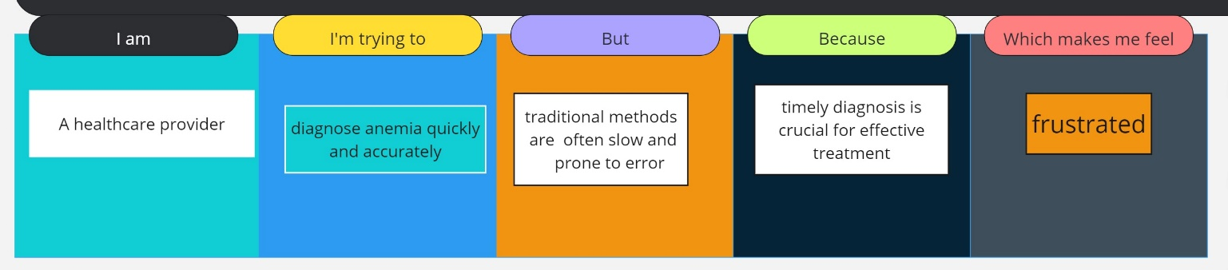

|  |  |  |  |  |  |
| --- | --- | --- | --- | --- | --- |
| **Problem**  **Statement (PS)** | **I am**  **(Customer)** | **I’m trying to** | **But** | **Because** | **Which makes me feel** |
| PS-1 | A healthcare provider | diagnose anemia quickly and accurately | traditional methods are often slow and prone to error | timely diagnosis is crucial for effective treatment | frustrated and concerned about patient outcomes |
| PS-2 | A patient | |  | | --- | | understand  if I have  anemia |  |  | | --- | |  | | |  | | --- | | existing tests  are invasiveand  inconvenient |  |  | | --- | |  | | |  | | --- | |  |   I want to manage  my health effectivey | |  | | --- | | anxious and  uncertain  about my  health status | |  |  |  | | --- | |  | |

|  |  |  |
| --- | --- | --- |
|  |  |  |